Introduction
More Inclusive Economies: The need for a Relational Approach

Across the globe, cities are increasingly looking for new ways of addressing issues of inequality and urban poverty by setting out to build more inclusive economies.
These approaches look beyond individualistic, market driven approaches serving private concerns.

A fundamental aspect of more inclusive economic approaches is the belief that a change in relationships based on solidarity and cooperation is essential in developing sustainable and inclusive economies, cities and city regions.
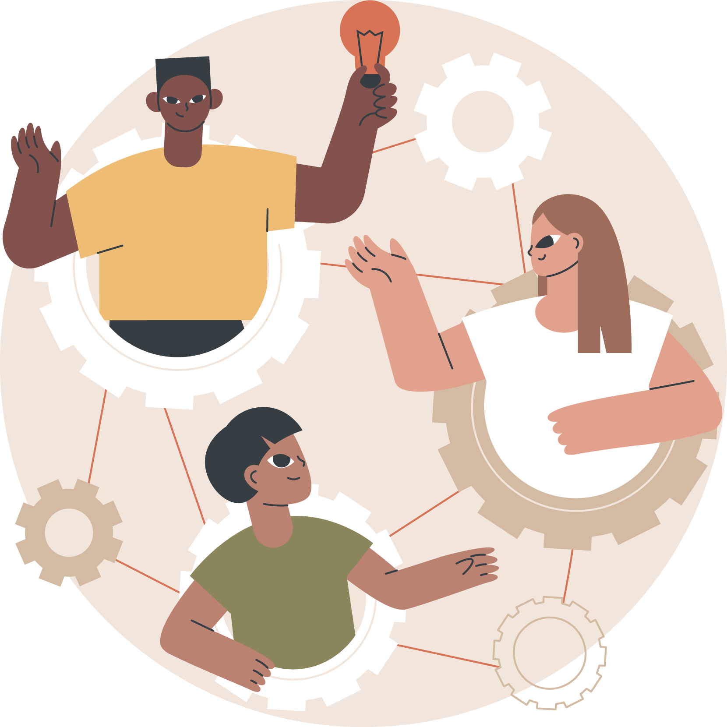
This suggests that, if we are to move towards more inclusive economic approaches, we also need to rethink our approaches to community engagement, starting by considering what type of relationships between communities and policymakers can best future proof inclusive places and economies.
A relational approach to engagement can help. Rather than beginning with an intervention, a relational approach starts by developing a different power dynamic in working with communities to develop strategic engagement policy and practice.

The founding principle of this approach is that:

relationships matter...engagement, then, should be about creating the relationships that provide a foundation for long- term and sustainable change (Warren, 2009, p.2248).

Relational Theory 1: Relational Goods

Relational theory focuses on how relationships can be established to generate the ‘relational goods’ (such as interpersonal trust, emotional support, care and social influence) (Cordelli, 2015) that are required if there is to be a fundamental shift to a more reciprocal relationship between the state, civil society and citizens (Mulgan, 2012).

Interpersonal trust – Cordelli refers to relational trust as playing an essential role in protecting what people care about in their everyday life, as we cannot possibly take care of everything, at every hour of the day, by ourselves. When we think about strategic and economic policy engagement, as a community we need to trust others and have a sense of security that those we have trusted will help us to achieve what we want to achieve.

Emotional support and care are produced by and available within face-to-face, ongoing relationships, but can also be generated in relationships among and between different stakeholders. In communities experiencing times of challenge, upheaval and change, it is particularly important to acknowledge that emotional support is a core human need, on par with the need for food and sanitation, and necessary to maintain a basic level of physical and mental health.

Social influence is about being able to enhance the strength of one’s claims or the socially perceived worth of one’s own projects, by building relationships that can bring others to share and support those claims and projects. A more relational approach should understand the importance of a reciprocal approach, with a focus on how community members can develop social influence, rather than focusing only on the influence that policymakers and professionals have over the

Audit 1: Generating Relational Goods

The audit activities in this Toolkit provide a way of identifying more-or-less relational approaches to engagement in practice and of thinking differently about how we approach community engagement activities for more inclusive strategic and economic policymaking.
The audit activities help us to try and understand the catalysts for more-or-less-relational approaches to engagement. The data gathered can then be used to analyse current approaches, for example mapping out relational approaches geographically and comparing with existing data such as socio-economic indicators.

Activity 1:
- In your work team, decide on 3-4 community engagement activities to consider.
- Work separately to complete a proforma for each engagement activity before considering the questions.
- Come back together as a team to compare and discuss any emerging patterns or themes.
- Think about reciprocity when considering the relational goods, for example how it was evident that the policymakers trusted community members and vice versa?

Note down any patterns and consider:
- Do certain project locations or the engagement of certain stakeholders appear to influence the relational goods that are generated? Why might this be so?
- Does the funding or duration of the project have any impact on the development of relational goods? In what ways?
- Has the generation of relational goods (or the lack of them) affected project outcomes?

Audit 1: Generating relational goods
Activity | Location | Funding/Duration | Key Stakeholders | Outcomes
Evidence of the generation of interpersonal trust: |  |  | Areas for development:
Evidence of the generation of emotional support & care: |  |  | Areas for development:
Evidence of the generation of social influence: |  |  | Areas for development:

